PSFML Worksheet (Ungraded practical Work)

1. A box contains 10 ICs, one of them is defective. They are being tested one by one. If the IC is found to be good, it is placed in a separate box, and if it is bad then it is thrown away. Find the probability the defective IC is found in the first 4 trials. (Use basic conditional probability).
2. Given the discrete CDF shown; find the probabilities;

* 1. P(x = 7)
  2. P(x = 3)
  3. P(x < 4)
  4. P(x >= 2.5)

1. For the following graphs, state which of the following graphs resembles a valid (discrete) CDF and which doesn’t. Justify!

Figure a Figure b

Figure c Figure d

1. If X is an RV with Gaussian distribution with mean m = 1 and standard deviation σ = 2, find the probability that; (normal distribution, use the 68 95 99 rule)
   1. X > 1
   2. X = 1
   3. -1 < X < 3
   4. 1 < X < 3
   5. X < -5
   6. X > -3
2. Consider two random variables X and Y with joint PMF given

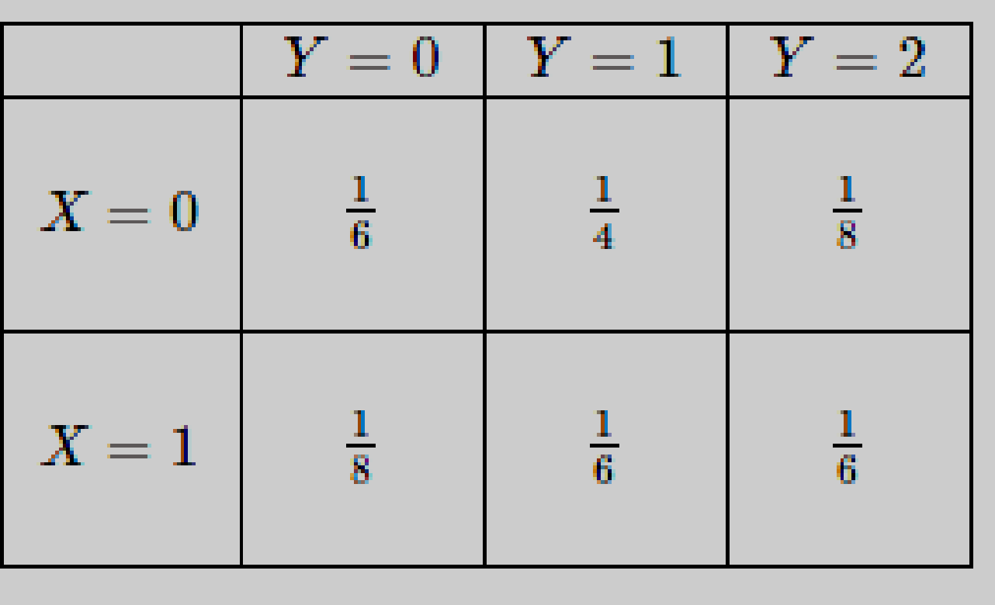

1. Find P(X=0,Y≤1).
2. Find the marginal PMFs of X and Y.
3. Find P(Y=1|X=0).
4. Are X and Y independent?
5. Let X be a discrete random variable with the following PMF below. Find and plot the CDF of X.

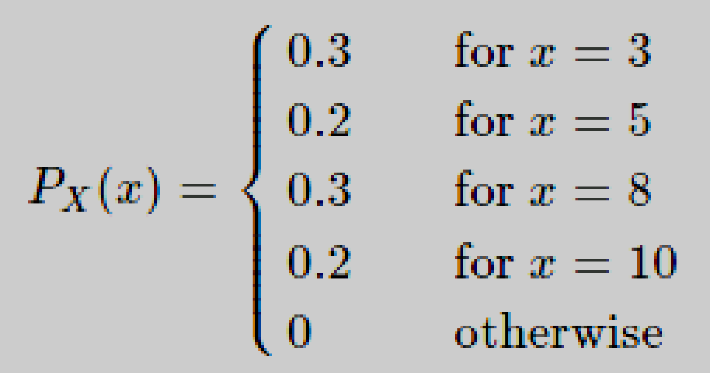

1. Let X be a discrete random variable with PMF. Define Y=X(X−1)(X−2). Find the PMF of Y.

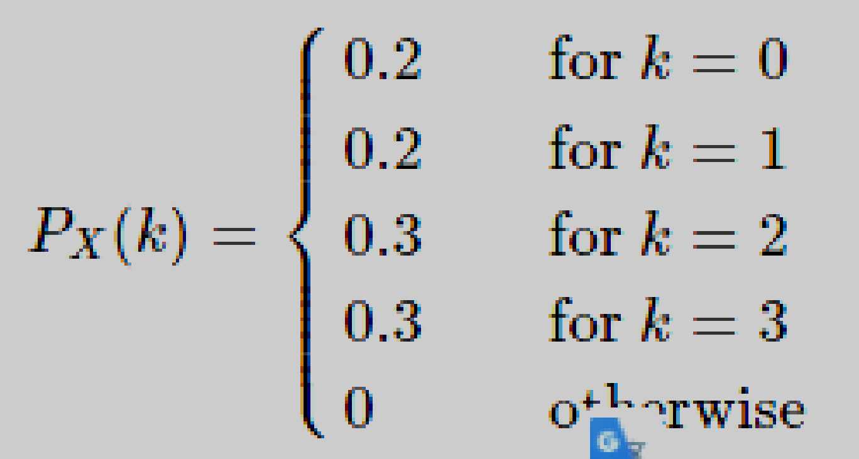

1. For an experiment of rolling two dice. You observe two random variables X and Y which are the dice roll value for the first and second die respectively:
2. Write down the outcome space of each random variable $S_{X}$ and $S_{Y}$.
3. Find P(X = 2, Y = 6)
4. Find (X>3|Y = 2)
5. Let Z be a random variable that Z = X + Y. Find $S_{Z}$ and the PMF of Z.
6. Find P(X=4|Z = 8)
7. Let X be a discrete random variable with the following PMF

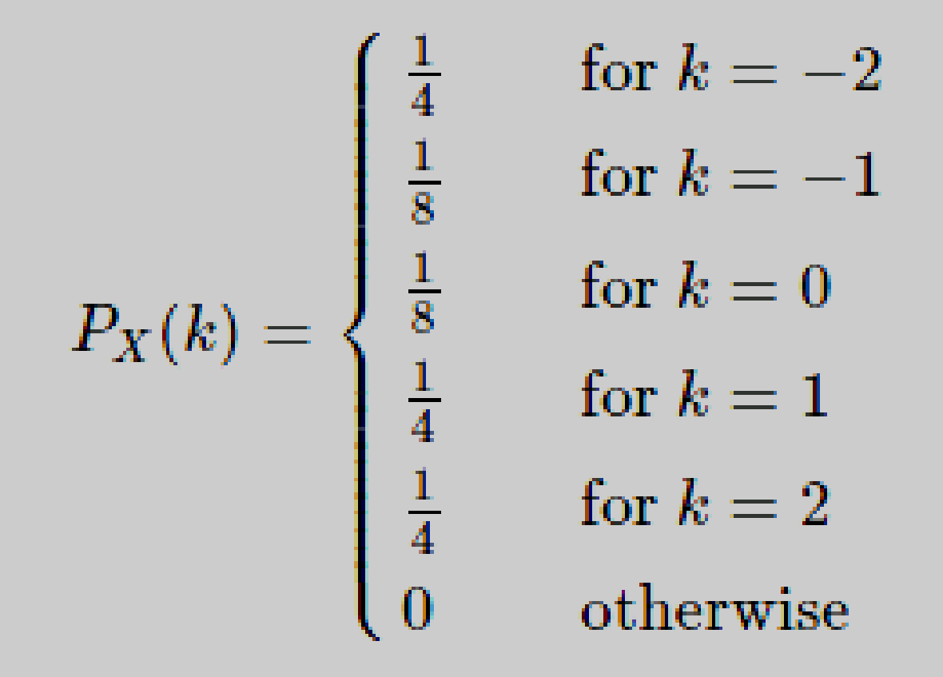

I define a new random variable Y as Y=(X+1)2.

1. Find the range of Y.
2. Find the PMF of Y.
3. The number of customers arriving at a grocery store is a Poisson random variable. On average 10 customers arrive per hour. Let X be the number of customers arriving from 10am to 11:30am. What is P(10<X≤15)?
4. If X∼Poisson(λ), find Var(X).
5. Let X be a continuous random variable with the following PDF

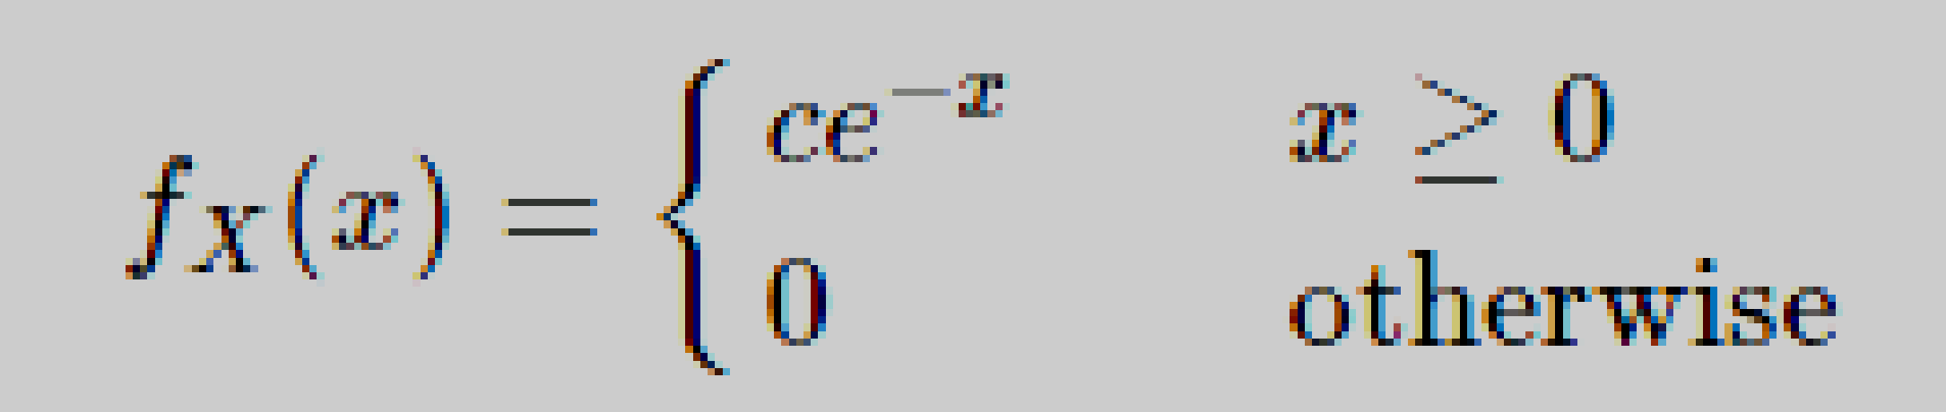

where c is a positive constant.

1. Find c.
2. Find the CDF of X, FX(x).
3. Find P(1<X<3).
4. Let X∼Uniform(−1,1) and Y=X2. Find the CDF and PDF of Y.
5. Suppose that the time between emergency calls to a small suburban fire station follows an exponential distribution with an average rate of 1.8 calls per day.
6. Phil the fireman has just clocked on. What is the chance of a call in the next 15 minutes?
7. Phil has nearly finished his shift: 15 minutes to go. There has been no call during his shift so far. What is the chance of a call in the next 15 minutes?
8. Judy works a 10-hour shift, Mondays to Thursdays. What is the probability that she has no calls in a shift?
9. What is the probability that she has no calls in four successive days?
10. Judy is talking about her job: ‘In 10% of shifts, there’s a call in the first x hours of the shift.’ What is x, to one decimal place?
11. Suppose that the difference between the forecast maximum temperature and the actual maximum temperature (in degrees Celsius) in a city is Normally distributed with mean 0 and standard deviation 1.2.
12. Find the probability that the actual maximum is within 1.0 degrees of the forecast maximum.
13. Which is more likely: an underestimate of 0.5 degrees or more, or a forecast within 0.5 degrees of the actual maximum?
14. To evaluate a new test for detecting Hansen’s disease, a group of people 5% of which are known to have Hansen’s disease are tested. The test finds Hansen’s disease among 98% of those with the disease and 3% of those who don’t. What is the probability that someone testing positive for Hansen’s disease under this new test actually has it?